ASH & BRASS
Prototype Design Bible v0.4 - BULLET HEAVEN EDITION
A darkly funny bullet heaven action RPG about building a rebellion inside a moving corporate fortress that eats time.
Canon update: ASH & BRASS is no longer framed as a manual bulletstorm/slasher. It is a bullet heaven / survivor-like action RPG. The player steers Wren through chaos, makes build choices, triggers key abilities, and upgrades a ridiculous machine of automatic steampunk violence.
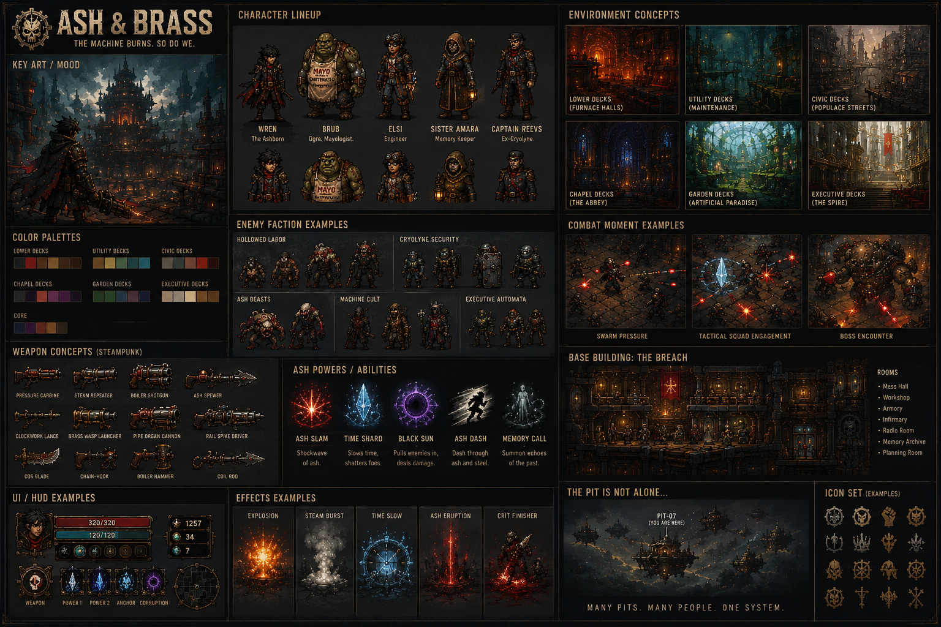

Table of Contents
- 1. Current One-Sentence Pitch
- 2. Full Game Plan
- 3. Genre Pivot: Bullet Heaven
- 4. Story and World Premise
- 5. The Pit, Cryolyne, and Social Hierarchy
- 6. Factions: The Transitioned Edition
- 7. Tone, Humor, and Weird Character Rules
- 8. Core Loop
- 9. Mission Combat and Auto-Weapon Rules
- 10. Weapons, Builds, and Progression
- 11. Tactical Horde AI in a Bullet Heaven Game
- 12. Base Building, Outposts, and Pushback
- 13. Corruption, Anchor, and Endings
- 14. Characters and Crew
- 15. Visual Art Direction
- 16. Branding Guide
- 17. Music, Audio, and Streamer Mode
- 18. Website / Marketing Copy Direction
- 19. Prototype / Vertical Slice Scope
- 20. Art Prompt Library
- 21. Legacy Art Appendix

1. Current One-Sentence Pitch
ASH & BRASS is a darkly funny bullet heaven RPG where you build a rebellion inside a time-harvesting corporate fortress, survive absurd hordes with overbuilt steampunk weapons, and decide how much of yourself to burn for power.
Positioning | Direction
Genre | Bullet heaven / survivor-like action RPG with base building and narrative systems.
Core fantasy | Wren becomes a walking industrial accident. The player survives, shapes, and upgrades the chaos.
Tone | Dark oppression, corporate satire, weird characters, and awkward comedy timing.
Visual identity | Stylized grimy steampunk. Not locked to pixel art. Pixel art can remain an optional prototype/reference style.
Core enemy | The Transitioned: loyal corporate volunteers fused to brass, badges, clipboards, and Cryolyne ideology.
Long-term reveal | The Pit is only one of many Pits in a wider harvest network.

2. Full Game Plan
The game is built around a repeating tension: Wren can explore and progress at his own pace, but The Pit notices rebellion. Missions create resources, story reveals, survivors, outposts, and threat. The Breach converts those discoveries into permanent power. Cryolyne pushes back through attacks, propaganda, sabotage, and organized Transitioned squads.
Layer | Purpose | Player Feeling
Bullet heaven missions | Auto-firing weapons, hordes, tactical enemy roles, upgrade choices | One more run; my build is becoming absurd.
Base building | The Breach grows from hideout to rebellion hub | I have a home worth defending.
Outposts | Local safe zones, vendors, shortcuts, quests, regional upgrades | The Pit is big and strange.
Pushback | Cryolyne retaliates without constant nagging | The machine is alive, but my base can answer.
Corruption / Anchor | Power tradeoffs affect gameplay and ending | Strength has consequences.
Weird cast | Odd NPCs give utility, humor, emotion, and secrets | The rebellion is full of memorable freaks.

3. Genre Pivot: Bullet Heaven
The player should not manually aim every shot. The core gameplay is movement-first survival and build-crafting. Weapons and powers fire automatically based on targeting rules, cooldowns, trigger conditions, and upgrades. The player controls movement, dash, positioning, pickup routes, active abilities, ultimate timing, interactions, and upgrade choices.
Old Framing | New Framing
Manual bulletstorm/slasher | Bullet heaven / survivor-like action RPG.
Player aims every weapon | Most weapons auto-fire; player steers the apocalypse.
Combat depth from shooting skill | Combat depth from movement, positioning, build synergy, tactical enemies, and timing.
Pixel art as mandatory | Stylized steampunk art direction; pixel art optional. Expressive humor matters.
Hordes only | Hordes plus tactical enemy squads and terrain problems.

Combat north star: The player does not aim the apocalypse. The player survives it, shapes it, and upgrades it until the screen becomes a ridiculous machine of consequences.

4. Story and World Premise
Wren was an orphan left with a shard of impossible glass. He became a mercenary because survival was the only thing the Ground taught cleanly. A sabotage contract sent him into The Pit, a moving fortress-city controlled by Cryolyne Corporation. Inside the core, Wren absorbed stolen time and came back carrying ash, memory, and proof.
The people inside The Pit know the machine is cruel, but rationing, propaganda, geography, and fear keep them trapped. Wren does not need to tell them they are oppressed. He needs to prove the machine can bleed.
Story Spine | Meaning
Wren enters The Pit for money | He begins as a survivor, not a hero.
The core fills him with stolen time | The ash gives power and burden.
He builds The Breach | The rebellion becomes physical, not theoretical.
He moves through decks and outposts | The player learns the fortress as a society.
He confronts Cryolyne and The Chairman | The system has a face, ego, and absurd language.
The Pit is one of many | The fight becomes bigger than one machine.

5. The Pit, Cryolyne, and Social Hierarchy
The Pit is not a dungeon. It is a moving society that must keep running. It has schools, kitchens, worship halls, utility decks, gardens, outposts, black markets, prisons, propaganda offices, executive lounges, and forgotten crawlspaces. Cryolyne's control comes from dependency: if The Pit stops, people believe everyone dies.
Deck / Layer | Role | Tone
Executive Decks | Cryolyne leadership, luxury, surveillance | Clean, gold, fake calm, Chairman statues.
Garden Decks | Artificial paradise for selected citizens | Beautiful and morally rotten.
Chapel Decks | Machine faith, propaganda, confession | Corporate religion and HR spirituality.
Civic Decks | Normal families, schools, markets | Small lives under giant lies.
Utility Decks | Power, water, weapons, maintenance | Steam, pressure, valves, engineering superstition.
Lower Decks | Labor, ration lines, debtbound workers | Rust, heat, survival, community.
The Core | Time extraction and impossible ash | Final truth, endings, identity fracture.

6. Factions: The Transitioned Edition
The primary enemy faction is The Transitioned, not consumed victims. They are corporate loyalists who volunteered for augmentation, status, and permanent usefulness. They still file reports. They still salute. They are funny because they are bureaucratic monsters, and dangerous because they willingly serve the system.
Faction | Canon Description
CRYOLYNE CORPORATION | The rulers. The Chairman believes the Pits are the only way. Control through fear, information, ration, and tremendous ego.
THE TRANSITIONED | Not victims - volunteers. Middle managers, security, and sycophants who chose augmentation to serve forever. Employee badges, ID numbers, welded corporate armor.
THE MACHINE CULT | Priests of the Core. They worship function. Their faith is a lie they tell to feel important.
THE REBELLION | Those who refuse to be consumed. Small, scattered, growing despite the Chairman calling them losers.
SCAVENGER CLANS | Independent survivors, smugglers, opportunists, misfits, and outside-world liars. Better dressed than The Transitioned.

Brub-type ogres are not Transitioned by default. Brub is comic relief, morale anchor, and possible ally - huge, awkward, gentle, and obsessed with mayonnaise.

7. Tone, Humor, and Weird Character Rules
The game should be funny without becoming weightless. Humor should come from bureaucracy, denial, class absurdity, weird NPCs, and perfectly timed interruptions. Serious tragedy remains serious. The surrounding systems are ridiculous.
Comedy Source | Example
Awkward interruption | Wren finds a worker expiration ledger. Brub enters asking whether upper-deck mayo is supposed to taste like curtains.
Corporate language | Cryolyne says workers are not consumed; they are transitioned into final utility.
Enemy behavior | Shield units salute before attacking. Commanders check clipboards while formations collapse.
Environmental jokes | Safety posters beside corpse grinders; propaganda posters with grease-pencil mustaches.
Character contradiction | The most moral accountant in The Pit sounds like a scammer.
Mechanics as jokes | Brub support can repel an attack, move rockets into cold storage, and improve morale accidentally.

Rule: the joke is never that people suffer. The joke is the absurd machine that explains the suffering with policy, slogans, audits, and lunch schedules.

8. Core Loop
Phase | Description
Return to The Breach | Talk to crew, craft, upgrade, assign defenders, manage corruption, choose next route.
Pick mission / outpost | Choose a deck, objective, risk modifier, or distress response.
Survive bullet heaven run | Move, dodge, collect, position, trigger actives, choose temporary upgrades.
Discover | Find secrets, survivors, strange NPCs, weapon schematics, Memory Echoes, or outposts.
Extract or push | Return safely or risk deeper rewards and higher threat.
Resolve fallout | Base grows, outposts strengthen, Cryolyne Pushback evolves, endings shift.

The game should let players go at their own pace. Threat should build gradually. A strong base should reduce mandatory responses so the player feels prepared, not nagged.

9. Mission Combat and Auto-Weapon Rules
Bullet heaven combat is about steering an escalating system. Wren's weapons and powers auto-fire based on rules. The player decides where to stand, what to collect, when to dash, when to trigger active abilities, and what upgrades to choose.
System | Rule
Auto weapons | Fire on cooldown or trigger rules: nearest enemy, densest group, elite priority, shield priority, low-health execute, around-player orbit.
Active abilities | Player-controlled dash, panic button, ultimate, black sun pull, time fracture, or emergency burst.
Temporary upgrades | Offered during missions; change behavior, not just numbers.
Readable chaos | Enemy projectiles and danger zones must remain clear even when player effects are wild.
Positioning matters | Walls, vents, shield lines, bomb arcs, and enemy formations force movement decisions.
Extraction choice | Players can leave with resources or push deeper for secrets and risk Pushback escalation.

10. Weapons, Builds, and Progression
Weapons should feel like overbuilt steampunk devices that automatically create mayhem. Each weapon family levels through use. Armor and ash powers also gain mastery. Builds should feel absurdly strong against some problems and uncomfortable against others.
Auto-Weapon | Behavior | Funny Identity
Cogblade Halo | Saws orbit Wren; later detach, deflect, or seek elites | Personal space enforcement.
Brass Wasp Launcher | Tiny homing rockets launch on cooldown | Explosive employees with excellent attendance.
Pipe Organ Cannon | Fires rocket hymns toward dense enemy clusters | Illegal in six decks and three religions.
Kettle Mortar | Lobs arcing bombs over walls | A hot beverage for people you dislike.
Chain-Hook | Yanks priority enemies, resources, or shield units | Human Resources, but literal.
Chrono Pistol | Delayed bullets hang, then fire again | Always late. Never sorry.
Boiler Hammer | Auto-slams when surrounded | Subtlety was laid off.
Memory Blades | Spectral blades strike or execute enemies | The dead have notes.

11. Tactical Horde AI in a Bullet Heaven Game
Tactical AI is still important because auto-weapons can be blocked, redirected, wasted, or forced into suboptimal targets. The player counters enemy tactics through movement, active abilities, build choices, and upgrades.
Enemy Role | Bullet Heaven Problem | Player / Build Answer
Shield Unit | Auto-fire wastes damage into shields | Flank, hooks, bombs, shield-priority rockets, armor shred.
Bomber | Attacks over cover and punishes camping | Move, rush, anti-artillery, arcing counter-fire.
Commander | Keeps squads organized and formations effective | Elite-target builds, ultimates, assassination movement.
Wallbreaker | Opens new routes for hordes and ruins safe zones | Burst damage, slows, mines, defensive upgrades.
Support | Keeps tactical groups alive | Priority targeting, chain lightning, teleport, debuffs.
Flanker | Punishes kiting and tunnel vision | Orbitals, traps, saw halo, rear awareness cues.

Director rule: do not constantly hard-counter the player. Let builds shine, then introduce readable problems that ask for adaptation.

12. Base Building, Outposts, and Pushback
The Pushback System makes The Pit reactive without turning the game into chores. Cryolyne, The Transitioned, ash beasts, propaganda systems, and the machine itself respond to rebellion activity. Outposts may request help. If ignored, facilities can be damaged or temporarily disabled. If the base is strong, NPCs and defenses can handle most pressure.
Pushback Rule | Implementation
No constant interruptions | Threat grows through soft timers and visible warnings.
Preparation reduces babysitting | Defense readiness, turrets, staff, routes, and morale let bases handle attacks.
Failure creates missions | Damaged rooms unlock recovery objectives instead of dead ends.
Success creates rewards | Repelled attacks yield scrap, intel, morale, prisoners, and weapon parts.
Outposts feed The Breach | Local questlines send people, tech, routes, or passive bonuses home.
Humor remains | Brub can defend the pantry, misclassify the armory as a pantry, and still somehow help.

13. Corruption, Anchor, and Endings
Corruption is temptation, not a simple bad meter. Traits give strong benefits and real costs. Anchor represents Wren's remaining selfhood: memory, promises, relationships, and human restraint. The ending is shaped by visible meters, hidden flavor tracks, survivor trust, base strength, and final core choices.
Track | Build Benefits | Ending Pressure
Ash Hunger | Kills heal, explosions chain, damage rises | Ash King, monster, sacrifice outcomes.
Time Fracture | Rewinds, repeats, cooldown distortion | Loop, hidden, unstable outcomes.
Machine Bond | Drones, turrets, hacks, mechanical weapons | Control, merge, machine-saint outcomes.
Memory Burden | Spectral allies, hidden rooms, lore power | Choir, release, martyr outcomes.
Anchor | Trust, healing, stability, liberation routes | Rebellion, severance, humane outcomes.

Trait rename remains canon: Hollow Kin is now Hostile Takeover - Wren hijacks Transitioned command protocols and turns corporate hierarchy against itself.

14. Characters and Crew
The rebellion should feel like a weird crew. Every major character needs a silhouette, base function, secret, funny contradiction, and possible consequence. Characters can be ridiculous, but the best ones eventually matter emotionally.
Character | Function / Design Rule
Wren | Ashborn player character; dry, haunted, straight man to the madness.
Brub | Ogre mayologist; morale, food, accidental defense, comic relief; not Transitioned.
Elsi Varn | Engineer; weapon crafting, upgrades, former augmentation designer.
Sister Amara | Memory Keeper; Anchor, Memory Archive, spiritual tension.
Captain Reeves | Ex-Cryolyne; tactics, enemy formations, guilt.
Mott the Unpaid | Ledger rat; hides living people through falsified records.
Auntie Voss | Lower-deck cook; morale, food buffs, insults Wren into decency.
Juniper Bell | Propaganda singer; broadcasts, morale, class guilt.
Latch | Door technician; routes, shortcuts, deeply unhealthy door philosophy.
Nixie Quell | Dust Rider pilot; outside world, many-Pits reveal.
Mother Cinder | Ash oracle; forbidden traits and dangerous truth.
The Chairman | Orange-tinted face, ash-combover, gold suit, tiny hands, ego made flesh.

15. Visual Art Direction
Updated visual direction: stylized grimy steampunk bullet heaven. Do not lock the game to pixel art. Pixel art remains useful for prototyping and legacy reference, but the primary art direction can be stylized 2.5D, illustrated 3D, high-resolution 2D, painterly top-down, or another readable style.
Art Rule | Direction
Camera | Top-down or 3/4 isometric for readable hordes, rooms, outposts, and base spaces.
Characters | Exaggerated silhouettes, expressive animation, strong faction reads, funny body language.
Materials | Brass, rust, soot, iron, steam, cracked glass, ash crystal, propaganda paper, worker cloth.
Combat VFX | Colorful, punchy, readable. Big but not blinding. Streamer mode can reduce effects.
Humor animation | Salutes, clipboard checks, wrong-way shields, Brub waddling into serious moments.
Not required | Do not require pixel art. Do not require realism. Do not make everything brown.
Visual target | Dark industrial world + absurd corporate details + satisfying overbuilt weapons.

16. Branding Guide
Branding should sell the real identity: funny, oppressive, explosive, weird, and strategic. The game is not just grim steampunk. It is corporate apocalypse comedy with survivor-like chaos and meaningful base progression.
Brand Element | Direction
Primary tagline | A darkly funny bullet heaven RPG inside a moving fortress that eats time.
Short pitch | Build a rebellion. Survive absurd hordes. Weaponize ridiculous steampunk machinery. Try not to become employee of the month.
Logo feel | Heavy brass lettering, ash cracks, industrial stamp marks, slight propaganda-poster energy.
Color palette | Brass gold, rust orange, soot black, ash gray, furnace red, corrupted purple, time blue.
Marketing tone | Cinematic and weird; less technical dashboard language, more game fantasy.
Enemy branding | The Transitioned should be corporate before monstrous: badges, numbers, slogans, salutes.
Chairman branding | His face appears everywhere: posters, statues, stamps, ration cards, executive portraits.

17. Music, Audio, and Streamer Mode
Music should be fun, wild, and intense when chaos escalates. The soundtrack should feel like a machine-city having a panic attack: distorted brass, junkyard percussion, dirty guitar, worker chants, clock ticks, steam hisses, and sudden comic stingers.
Feature | Direction
Combat layers | Exploration -> pressure -> tactical squad -> elite -> full bullet heaven panic.
Boss music | Theatrical, faction-specific, phase-shifting, industrial and catchy.
Comedy audio | Enemy barks, PA announcements, Brub interruptions, corporate jingles.
Streamer mode | Copyright-safe music, music-off option, reduce particles, reduce gore, reduce flashes, clearer outlines.
Clip design | Insane clears, weird NPC interruptions, Chairman propaganda, Brub support, corruption choices.

18. Website / Marketing Copy Direction
The site should not lead with technical systems or a rigid design-dashboard feeling. Lead with fantasy, tone, and identity. Then let visitors dig into systems. The current site can keep a developer dashboard page, but the homepage should sell the game.
Website Section | Copy Direction
Hero | ASH & BRASS - A darkly funny bullet heaven RPG inside a moving fortress that eats time.
Premise | You are building a rebellion from the inside of a machine that calls exploitation survival.
Combat | Move, dodge, and steer a growing storm of automatic steampunk weapons.
Base | Return to The Breach to upgrade, recruit, argue with weirdos, and survive Cryolyne Pushback.
Humor | Corporate monsters salute before attacking. Brub wants his mayo back. The Chairman is everywhere.
Systems | Corruption, Anchor, Pushback, outposts, weapon mastery, tactical horde AI.
CTA | Join the rebellion / Enter The Pit / Review the design bible.

19. Prototype / Vertical Slice Scope
The first playable version should prove the feel of bullet heaven combat and the loop back to base. Do not build the entire game. Build one small but polished slice that proves chaos, humor, tactics, and progression.
Component | v0 Slice Scope
Player | Wren movement, dash, pickup radius, one active ash ability, one ultimate.
Auto weapons | Cogblade Halo, Brass Wasp Launcher, Kettle Mortar, Chrono Pistol prototype.
Enemies | Swarmer, Shield Unit, Bomber, Commander, Flanker.
Arena | Lower-deck room with walls, vents, destructible cover, extraction point.
Base | The Breach with Forge, Mess Hall, one NPC, one upgrade.
Humor beat | Brub appears during or after a serious reveal.
Pushback | One warning and one optional defense resolution.
Win condition | Survive 10 minutes, defeat Transitioned supervisor, return with upgrade material.

Definition of done: one auto-weapon feels excellent, one tactical enemy formation changes movement, one joke lands, one upgrade makes the next run meaningfully different.

20. Art Prompt Library
Use these prompts for new art direction. They intentionally do not require pixel art.
MAIN ART DIRECTION PROMPT: Create a high-resolution ASH & BRASS visual style guide for a darkly funny bullet heaven RPG. Stylized grimy steampunk, top-down/isometric action game perspective, expressive characters, exaggerated silhouettes, overbuilt automatic weapons, brass/rust/ash color palette, corporate apocalypse satire. Show Wren as an ash-powered rebel, Brub as a huge gentle ogre with a MAYO apron, The Transitioned as corporate loyalists fused to brass with employee badges and clipboards, and The Chairman as an orange-faced narcissistic executive in a gold-plated brass suit with ash-combover and tiny hands on propaganda posters. Include combat readability examples: auto-firing homing rockets, orbiting cogblades, kettle mortars, chain hooks, enemy shield formations, and streamer-mode clarity. Do not make it strict pixel art; make it stylized, cinematic, readable, funny, and game-production friendly.
SITE HERO IMAGE PROMPT: ASH & BRASS key art, darkly funny steampunk bullet heaven RPG, Wren standing inside a moving fortress deck while automatic cogblades, brass wasp rockets, kettle bombs, and ash powers spiral around him, hordes of corporate-brass Transitioned enemies charging in formation, Brub in the background holding a jar of mayo at the worst possible time, propaganda poster of The Chairman on the wall, dramatic rust and brass lighting, readable action composition, not pixel art, stylized game concept art.
CHARACTER LINEUP PROMPT: ASH & BRASS character lineup, stylized grimy steampunk game art, Wren, Brub, Elsi, Sister Amara, Captain Reeves, Mott the Unpaid, Auntie Voss, Juniper Bell, Latch, Nixie Quell, Mother Cinder, The Chairman. Exaggerated silhouettes, readable from game camera, funny memorable details, brass/rust/ash palette, design bible notes, not strict pixel art.

21. Legacy Art Appendix
These earlier pages are retained as reference material. Future art should update from strict pixel language to stylized steampunk bullet heaven language.
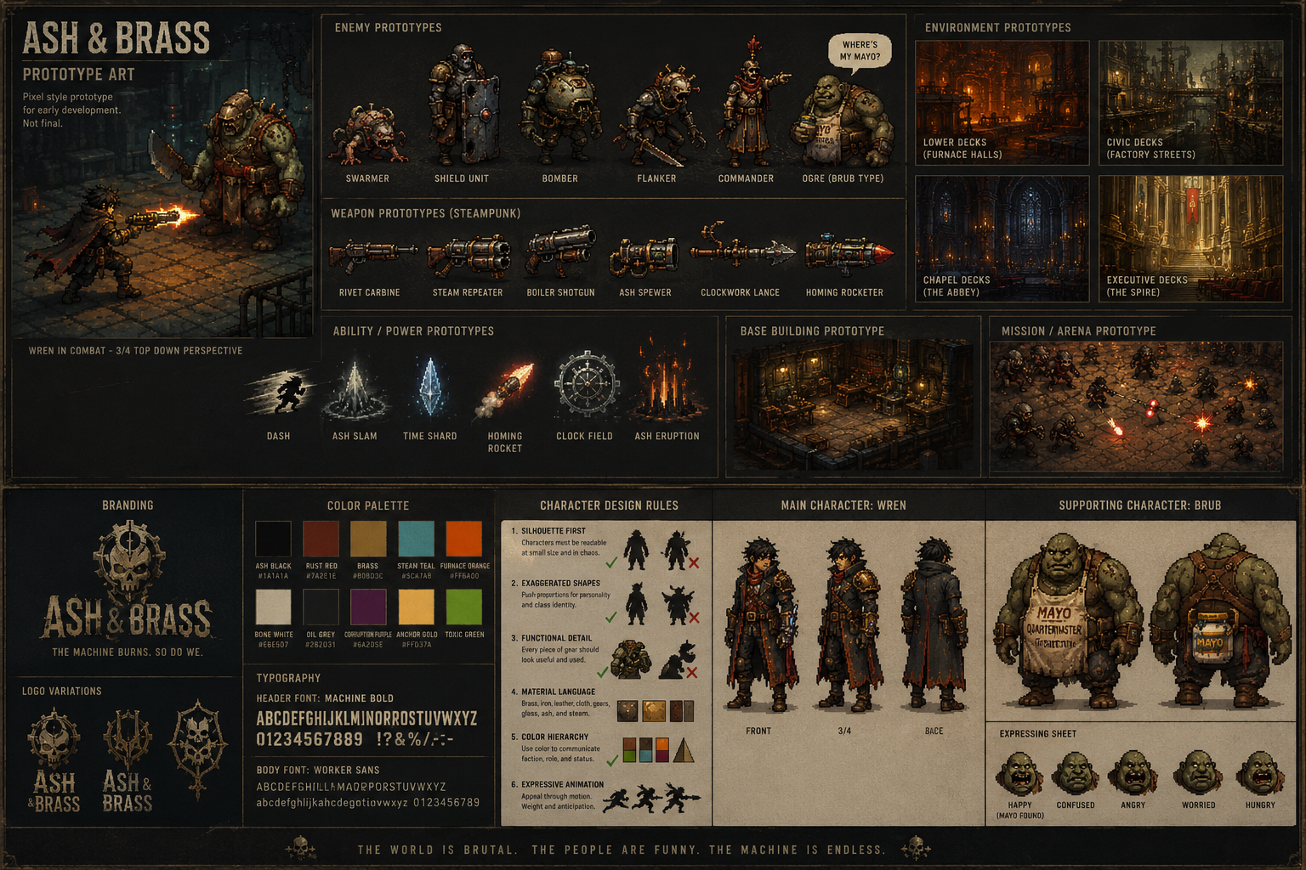
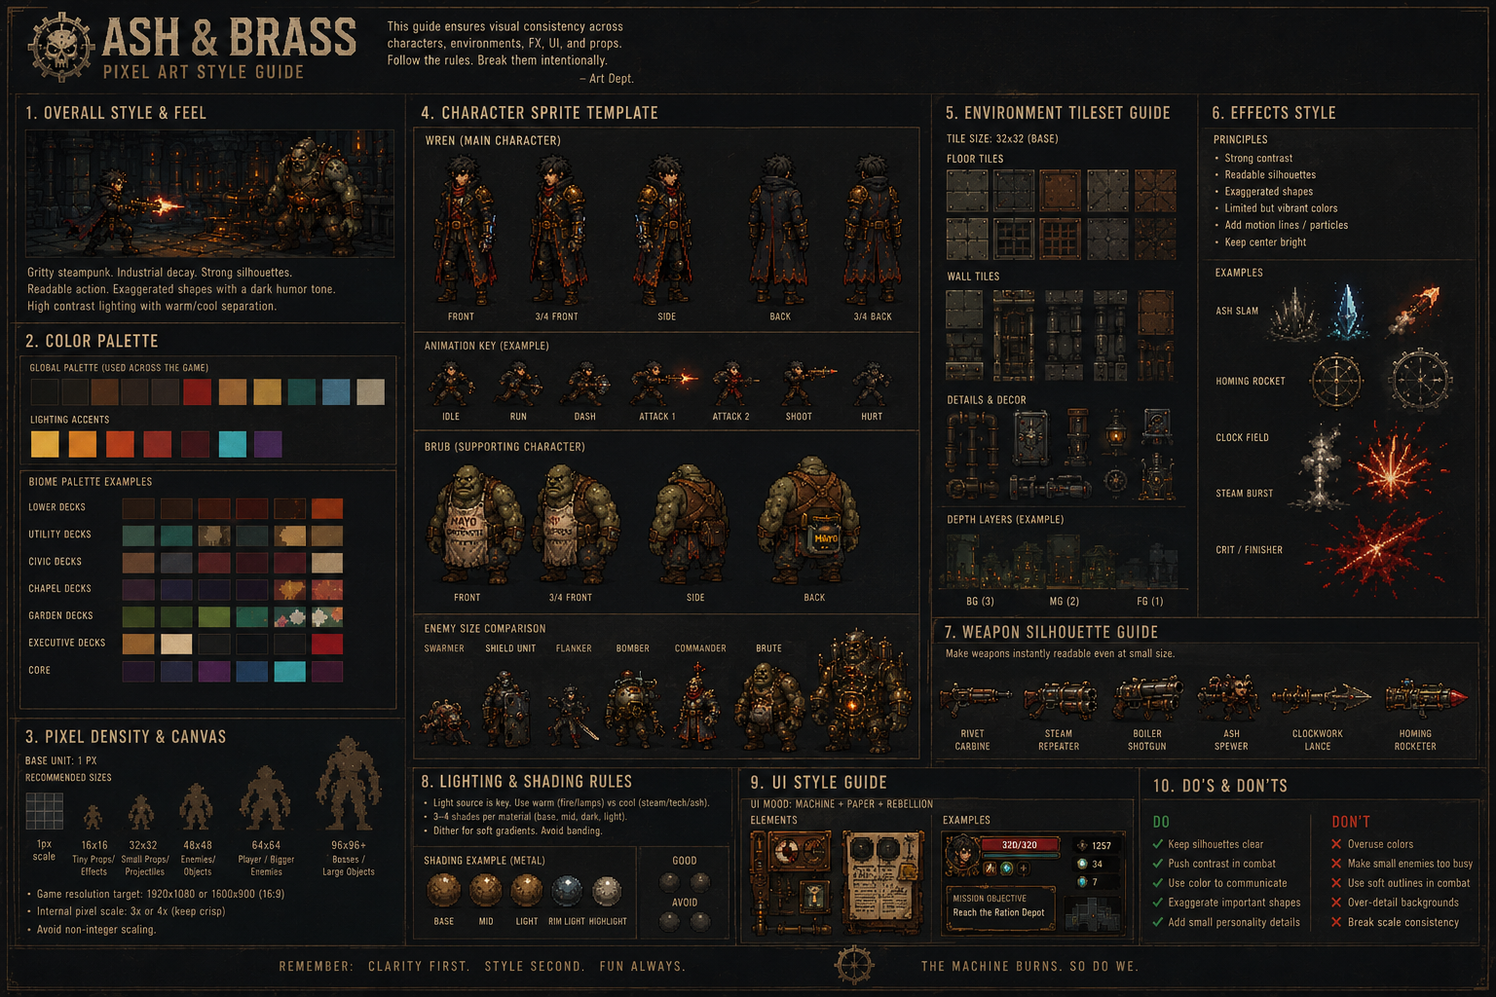
Legacy note: pixel art can still be used for prototypes or final production if chosen later, but it is no longer a required brand constraint.

